**Department of Computer Science and Engineering**

|  |  |
| --- | --- |
| **Course Code:CSE321** | **Credits: 1.5** |
| **Course Name: Operating Systems** | **Semester: Sum’18** |

**Lab 02**

**Linux shell programming**

1. **Topic overview:**

Students will be introduced with the shell programming of linux. At the end of the lab they should solve some problems using linux shell.

**2. Lesson Fit:** Knowledge of basic commands of linux terminal is required.

**3. Learning outcome:**

* Upon successful completion of this Lab the student will be able to;
* Demonstrate how to use the following Shell commands: cat, grep, ls,more, ps, chmod, finger, ftp, etc.
* Use the following Shell constructs: test, if then, if then else, if then elif, for, while, until, and c
* Write moderately complex Shell scripts
* Make a Shell script executable.

**4.** **Anticipated Challenges and Possible Solutions :**

Students might face problems while execute the shell commands from file.

**Solutions:** Before executing the shells execute permission is to be given using the command **CHMOD.**

**5.**  **Acceptance and Evaluation**

Students will show their progress as they complete each task. They will be

marked according to their lab performance.

**6. Activity details:**

**First hour:**

1. Discussion on shell scripting

2. Basic syntax of shell script

3. Variables, conditions

4.. For loops and while loops

5. Functions , arguments and parameter

6. Study the provided file for shell scripting \

**Types of Shell**

There are two main shells in Linux:

**1**. The **Bourne Shell**: The prompt for this shell is $ and its derivatives are listed below:

* POSIX shell also is known as sh
* Korn Shell also knew as sh
* **B**ourne **A**gain **SH**ell also knew as bash (most popular)

**2.** **The C shell**: The prompt for this shell is %, and its subcategories are:

* C shell also is known as csh
* Tops C shell also is known as tcsh

**What is Shell Scripting?**

Shell scripting is writing a series of command for the shell to execute. It can combine lengthy and repetitive sequences of commands into a single and simple script, which can be stored and executed anytime. This reduces the effort required by the end user.

Let us understand the steps in creating a Shell Script

1. **Create a file** **using** a **vi** editor(or any other editor). Name script file with **extension .sh**
2. **Start** the script with **#! /bin/sh**
3. Write some code.
4. Save the script file as filename.sh
5. For **executing** the script type **bash filename.sh**

"#!" is an operator called shebang which directs the script to the interpreter location. So, if we use"#! /bin/sh" the script gets directed to the bourne-shell.

Let's create a small script -

***#!/bin/sh  
Ls***

Let's see the steps to create it -

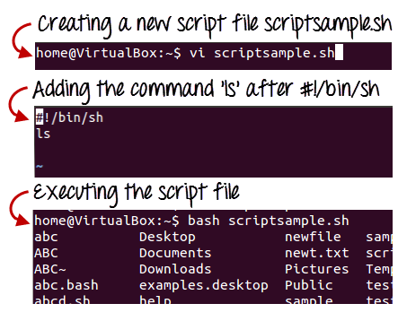

Command 'ls' is executed when we execute the script sample.sh file.

Adding shell comments

Commenting is important in any program. In Shell programming, the syntax to add a comment is

***#comment***

Let understand this with an example.

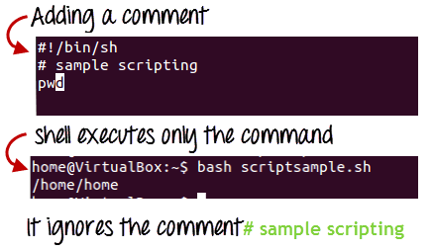

**What are Shell Variables?**

As discussed earlier, Variables store data in the form of characters and numbers. Similarly, Shell variables are used to store information and they can by the shell only.

For example, the following creates a shell variable and then prints it:

*variable ="Hello"  
echo $variable*

*Below is a small script which will use a variable.*

*#!/bin/sh  
echo "what is your name?"  
read name  
echo "How do you do, $name?"  
read remark  
echo "I am $remark too!"*

In this way all the variables are created and they are used in linux shell.

* **Second and third hour:** solve problems and evaluations

**Lab tasks**

1. Write a shell program which will output the name of all files to a text file.
2. Write a shell program which will read two numbers from a file and output the sum
3. Write a shell program which will calculate the age of a person from birthdate
4. Write a shell program which will count the number of files and directories in a specific directory
5. Write a shell program which will find the highest number among three numbers .
6. Write a shell program which will ask user for temperature in celsius and output the temperature in fahrenheit

**Home tasks:**

1. Write a shell program to see the contents of a directory.
2. Write a shell program to see the user log of the system
3. Write shell program to find out the gcd of two numbers
4. Write shell program to find the lcm of two numbers.